A PRESENTATION REPORT

On

***DIGITAL MODERN PERIODIC TABLE***

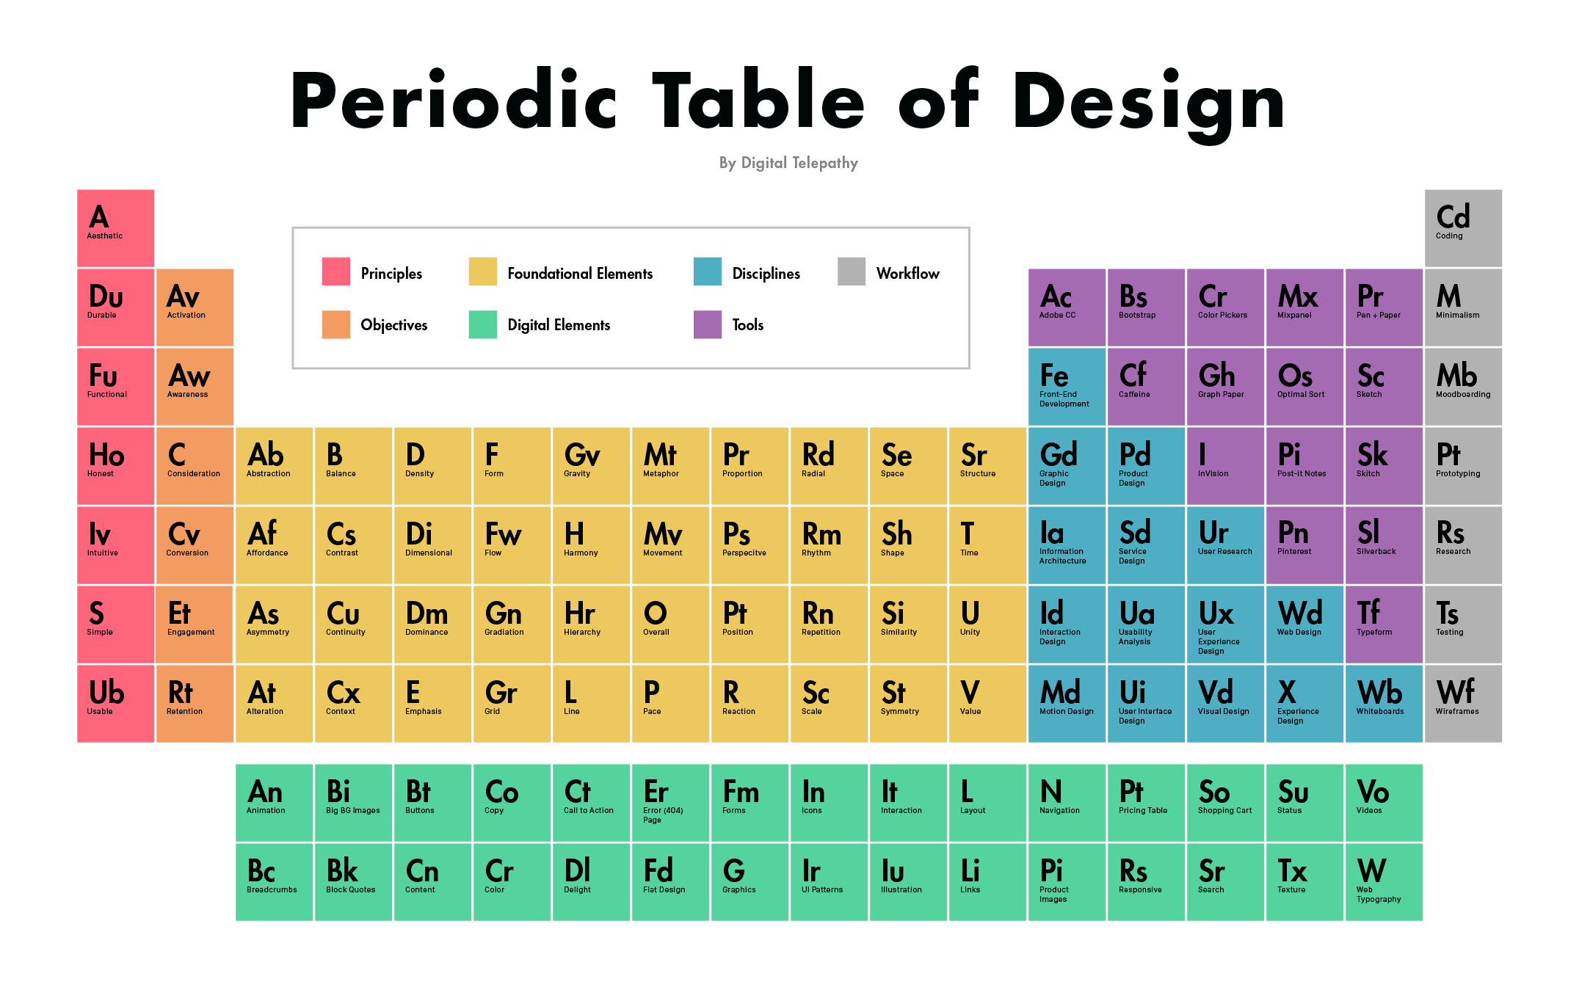

***Prepared by –***

***Rishikesh Mhetre – A26***

***Sanghavi Dorlikar – A28***

***Prathamesh Chavan – A36***

***Akshata Kulkarni – A37***

DIGITAL MODERN PERIODIC TABLE

##### A PRESENTATION REPORT

###### ***Submitted by***

***RISHIKESH MHETRE***

***SANGHAVI DORLIKAR***

***PRATHAMESH CHAVAN***

***AKSHATA KULKARNI***

***In partial fulfillment of the syllabus***

***Of***

# MINI PROJECT

# Second Year B.Tech. (Sem-II)

**Submitted to**

**The faculty of MINI PROJECT**

**DEPARTMENT COMPUTER SCIENCE AND ENGINEERING**

KIT’S COLLEGE OF ENGINEERING (Autonomous)

GOKUL SHIRGAON, KOLHAPUR

##### Faculty mentor

***Mr. A. B. Patil***

***April 2021***

**Kolhapur Institute of Technology’s**

**College of Engineering (Autonomous)**

**Gokul Shirgaon, Kolhapur**

Department of Computer Science and Engineering

*Faculty of Mini Project*

**CERTIFICATE**

This is to certify that **Rishikesh Mhetre(A26), Sanghavi Dorlikar(A28),** **Prathamesh Chavan(A36) and Akshata Kulkarni (A37), have** satisfactorilycompleted the project report entitled **“DIGITAL MODERN PERIODIC TABLE”** asa part of ISE of **Mini Project** (Sem-II) during the Academic Year 2020-21.

**Course Teacher HoD, CSE**

**Acknowledgment**

We would like to express our deep gratitude to Mr. A. B. Patil Sir, KIT’s College of Engineering, Kolhapur, for providing this opportunity to carry out this project of Mini Project. We are grateful to all faculties for providing academic inputs, guidance and encouragement throughout this period. We would like to express a deep sense of gratitude and thank Mr. A. B. Patil Sir without whose permission, wise counsel and able guidance, it would have not been possible to carry out our Mini Project in this manner.

Finally, we express my indebtedness to all who have directly or indirectly contributed to the successful completion of our Mini Project.

**INDEX**

|  |  |  |
| --- | --- | --- |
| **Sr.No.** | **Particulars** | **Page No.** |
| **1** | **Introduction** | **06** |
| **2** | **Overall Description** | **17** |
| **3** | **Specific Requirements** | **19** |
| **4** | **Other Non-Functional Requirements** | **20** |
| **5** | **Design** | **21** |
| **6** | **Activity Diagram** | **22** |
| **7** | **Results** | **23** |
| **8** | **Conclusion** | **26** |

**1. Introduction**

Digital Modern Periodic table is a simple project. C++ programming language is used to make this application. In this project, we can get the idea of how to create a science project related to making the periodic tables. We can search the elements both by their periodic name and their atomic number and also by its symbol. After we search the element, it will show you the results by displaying their details.

This program will help students to get the details regarding each element which are available within the periodic table. It will enable the students to get the details of each and every element by just one click. This program is easy to run and get details of each elements. Users have to just select the way they want to search for an element and then press enter to get information such as atomic number, their atomic value, their location in the periodic table, etc.

# 1.1 Problem Statement

Implementation of Digital Modern Periodic Table which is a simple educational console application using C++ programming Language.

**1.2 Project Scope**

The main purpose behind successfully making this project is to easily get the specified element and its properties in one click for the learning students. They don’t need to install any application, get disturbed by the adds that enter while using that application. It has tremendous scope in today’s pandemic situation where students can make use of this project and enjoy the E-Learning.

**1.3 Project Overview**

The following project report an be divided into four main parts that is, Introduction, Overall Descriptions, specific requirements and conclusion. In the Introduction part, we can get basic knowledge related to Digital Modern Periodic Table. In Overall description, we get information about what this particular Digital Modern periodic Table is all about and it is been implemented. One can understand requirements in specific requirements. Conclusion can give complete understanding of this project.

**1.4 Definitions, Acronyms, Abbreviation**

Modern Periodic Table –

The modern periodic table is used to organize all the known elements. Elements are arranged in the table by increasing atomic number. In the modern periodic table, each element is represented by its chemical symbol. Columns of the periodic table are called groups and the rows are known as period. Elements in the same group have similar properties.

## 118 Elements and Their Symbols and Atomic Numbers

|  |  |  |
| --- | --- | --- |
| **Name of the Element** | **Symbol of the Element** | **Atomic Number** |
| [Hydrogen](https://byjus.com/chemistry/hydrogen/) | H | 1 |
| [Helium](https://byjus.com/chemistry/helium/) | He | 2 |
| [Lithium](https://byjus.com/chemistry/lithium/) | Li | 3 |
| [Beryllium](https://byjus.com/chemistry/beryllium/) | Be | 4 |
| [Boron](https://byjus.com/chemistry/boron/) | B | 5 |
| [Carbon](https://byjus.com/chemistry/carbon/) | C | 6 |
| [Nitrogen](https://byjus.com/chemistry/nitrogen/) | N | 7 |
| [Oxygen](https://byjus.com/chemistry/oxygen/) | O | 8 |
| [Fluorine](https://byjus.com/chemistry/fluorine/) | F | 9 |
| [Neon](https://byjus.com/chemistry/neon/) | Ne | 10 |
| [Sodium](https://byjus.com/chemistry/sodium/) | Na | 11 |
| [Magnesium](https://byjus.com/chemistry/magnesium/) | Mg | 12 |
| [Aluminium](https://byjus.com/chemistry/aluminum/) | Al | 13 |
| [Silicon](https://byjus.com/chemistry/silicon/) | Si | 14 |
| [Phosphorus](https://byjus.com/chemistry/phosphorus/) | P | 15 |
| [Sulfur](https://byjus.com/chemistry/sulfur/) | S | 16 |
| [Chlorine](https://byjus.com/chemistry/chlorine/) | Cl | 17 |
| [Argon](https://byjus.com/chemistry/argon/) | Ar | 18 |
| [Potassium](https://byjus.com/chemistry/potassium/) | K | 19 |
| [Calcium](https://byjus.com/chemistry/calcium/) | Ca | 20 |
| [Scandium](https://byjus.com/chemistry/scandium/) | Sc | 21 |
| [Titanium](https://byjus.com/chemistry/titanium/) | Ti | 22 |
| [Vanadium](https://byjus.com/chemistry/vanadium/) | V | 23 |
| [Chromium](https://byjus.com/chemistry/chromium/) | Cr | 24 |
| [Manganese](https://byjus.com/chemistry/manganese/) | Mn | 25 |
| [Iron](https://byjus.com/chemistry/iron/) | Fe | 26 |
| [Cobalt](https://byjus.com/chemistry/cobalt/) | Co | 27 |
| [Nickel](https://byjus.com/chemistry/nickel/) | Ni | 28 |
| [Copper](https://byjus.com/chemistry/copper/) | Cu | 29 |
| [Zinc](https://byjus.com/chemistry/zinc/) | Zn | 30 |
| [Gallium](https://byjus.com/chemistry/gallium/) | Ga | 31 |
| [Germanium](https://byjus.com/chemistry/germanium/) | Ge | 32 |
| [Arsenic](https://byjus.com/chemistry/arsenic/) | As | 33 |
| [Selenium](https://byjus.com/chemistry/selenium/) | Se | 34 |
| [Bromine](https://byjus.com/chemistry/bromine/) | Br | 35 |
| [Krypton](https://byjus.com/chemistry/krypton/) | Kr | 36 |
| [Rubidium](https://byjus.com/chemistry/rubidium/) | Rb | 37 |
| [Strontium](https://byjus.com/chemistry/strontium/) | Sr | 38 |
| [Yttrium](https://byjus.com/chemistry/yttrium/) | Y | 39 |
| [Zirconium](https://byjus.com/chemistry/zirconium/) | Zr | 40 |
| [Niobium](https://byjus.com/chemistry/niobium/) | Nb | 41 |
| [Molybdenum](https://byjus.com/chemistry/molybdenum/) | Mo | 42 |
| [Technetium](https://byjus.com/chemistry/technetium/) | Tc | 43 |
| [Ruthenium](https://byjus.com/chemistry/ruthenium/) | Ru | 44 |
| [Rhodium](https://byjus.com/chemistry/rhodium/) | Rh | 45 |
| [Palladium](https://byjus.com/chemistry/palladium/) | Pd | 46 |
| [Silver](https://byjus.com/chemistry/silver/) | Ag | 47 |
| [Cadmium](https://byjus.com/chemistry/cadmium/) | Cd | 48 |
| [Indium](https://byjus.com/chemistry/indium/) | In | 49 |
| [Tin](https://byjus.com/chemistry/tin/) | Sn | 50 |
| [Antimony](https://byjus.com/chemistry/antimony/) | Sb | 51 |
| [Tellurium](https://byjus.com/chemistry/tellurium/) | Te | 52 |
| [Iodine](https://byjus.com/chemistry/iodine/) | I | 53 |
| [Xenon](https://byjus.com/chemistry/xenon/) | Xe | 54 |
| [Cesium](https://byjus.com/chemistry/cesium/) | Cs | 55 |
| [Barium](https://byjus.com/chemistry/barium/) | Ba | 56 |
| [Lanthanum](https://byjus.com/chemistry/lanthanum/) | La | 57 |
| [Cerium](https://byjus.com/chemistry/cerium/) | Ce | 58 |
| [Praseodymium](https://byjus.com/chemistry/praseodymium/) | Pr | 59 |
| [Neodymium](https://byjus.com/chemistry/neodymium/) | Nd | 60 |
| [Promethium](https://byjus.com/chemistry/promethium/) | Pm | 61 |
| [Samarium](https://byjus.com/chemistry/samarium/) | Sm | 62 |
| [Europium](https://byjus.com/chemistry/europium/) | Eu | 63 |
| [Gadolinium](https://byjus.com/chemistry/gadolinium/) | Gd | 64 |
| [Terbium](https://byjus.com/chemistry/terbium/) | Tb | 65 |
| [Dysprosium](https://byjus.com/chemistry/dysprosium/) | Dy | 66 |
| [Holmium](https://byjus.com/chemistry/holmium/) | Ho | 67 |
| [Erbium](https://byjus.com/chemistry/erbium/) | Er | 68 |
| [Thulium](https://byjus.com/chemistry/thulium/) | Tm | 69 |
| [Ytterbium](https://byjus.com/chemistry/ytterbium/) | Yb | 70 |
| [Lutetium](https://byjus.com/chemistry/lutetium/) | Lu | 71 |
| [Hafnium](https://byjus.com/chemistry/hafnium/) | Hf | 72 |
| [Tantalum](https://byjus.com/chemistry/tantalum/) | Ta | 73 |
| [Tungsten](https://byjus.com/chemistry/tungsten/) | W | 74 |
| [Rhenium](https://byjus.com/chemistry/rhenium/) | Re | 75 |
| [Osmium](https://byjus.com/chemistry/osmium/) | Os | 76 |
| [Iridium](https://byjus.com/chemistry/iridium/) | Ir | 77 |
| [Platinum](https://byjus.com/chemistry/platinum/) | Pt | 78 |
| [Gold](https://byjus.com/chemistry/gold/) | Au | 79 |
| [Mercury](https://byjus.com/chemistry/mercury/) | Hg | 80 |
| [Thallium](https://byjus.com/chemistry/thallium/) | Tl | 81 |
| [Lead](https://byjus.com/chemistry/lead/) | Pb | 82 |
| [Bismuth](https://byjus.com/chemistry/bismuth/) | Bi | 83 |
| [Polonium](https://byjus.com/chemistry/polonium/) | Po | 84 |
| [Astatine](https://byjus.com/chemistry/astatine/) | At | 85 |
| [Radon](https://byjus.com/chemistry/radon/) | Rn | 86 |
| [Francium](https://byjus.com/chemistry/francium/) | Fr | 87 |
| [Radium](https://byjus.com/chemistry/radium/) | Ra | 88 |
| [Actinium](https://byjus.com/chemistry/actinium/) | Ac | 89 |
| [Thorium](https://byjus.com/chemistry/thorium/) | Th | 90 |
| [Protactinium](https://byjus.com/chemistry/protactinium/) | Pa | 91 |
| [Uranium](https://byjus.com/chemistry/uranium/) | U | 92 |
| [Neptunium](https://byjus.com/chemistry/neptunium/) | Np | 93 |
| [Plutonium](https://byjus.com/chemistry/plutonium/) | Pu | 94 |
| [Americium](https://byjus.com/chemistry/americium/) | Am | 95 |
| [Curium](https://byjus.com/chemistry/curium/) | Cm | 96 |
| [Berkelium](https://byjus.com/chemistry/berkelium/) | Bk | 97 |
| [Californium](https://byjus.com/chemistry/californium/) | Cf | 98 |
| [Einsteinium](https://byjus.com/chemistry/einsteinium/) | Es | 99 |
| [Fermium](https://byjus.com/chemistry/fermium/) | Fm | 100 |
| [Mendelevium](https://byjus.com/chemistry/mendelevium/) | Md | 101 |
| [Nobelium](https://byjus.com/chemistry/nobelium/) | No | 102 |
| [Lawrencium](https://byjus.com/chemistry/lawrencium/) | Lr | 103 |
| [Rutherfordium](https://byjus.com/chemistry/rutherfordium/) | Rf | 104 |
| [Dubnium](https://byjus.com/chemistry/dubnium/) | Db | 105 |
| [Seaborgium](https://byjus.com/chemistry/seaborgium/) | Sg | 106 |
| [Bohrium](https://byjus.com/chemistry/bohrium/) | Bh | 107 |
| [Hassium](https://byjus.com/chemistry/hassium/) | Hs | 108 |
| [Meitnerium](https://byjus.com/chemistry/meitnerium/) | Mt | 109 |
| [Darmstadtium](https://byjus.com/chemistry/darmstadtium/) | Ds | 110 |
| [Roentgenium](https://byjus.com/chemistry/roentgenium/) | Rg | 111 |
| [Copernicium](https://byjus.com/chemistry/copernicium/) | Cn | 112 |
| [Nihonium](https://byjus.com/chemistry/nihonium/) | Nh | 113 |
| [Flerovium](https://byjus.com/chemistry/flerovium/) | Fl | 114 |
| [Moscovium](https://byjus.com/chemistry/ununpentium/) | Mc | 115 |
| [Livermorium](https://byjus.com/chemistry/livermorium/) | Lv | 116 |
| [Tennessine](https://byjus.com/chemistry/ununseptium/) | Ts | 117 |
| [Oganesson](https://byjus.com/chemistry/ununoctium/) | Og | 118 |

## **2. Overall Description**

## 

## **2.1 Product Overview**

Project is developed by using basic concepts of C++ programming. We provide the main menu options in the project from which you can select any. This program will help students to get the details regarding each element which are available within the periodic table. It will enable the students to get the details of each element by just one click. This program is easy to run and get details of each elements. Users have to just select the way they want to search for an element and then press enter to get information such as atomic number, their atomic value, their location in the periodic table, etc.

Once the program has been run, it will display the Home screen displaying welcome and the people behind this project.

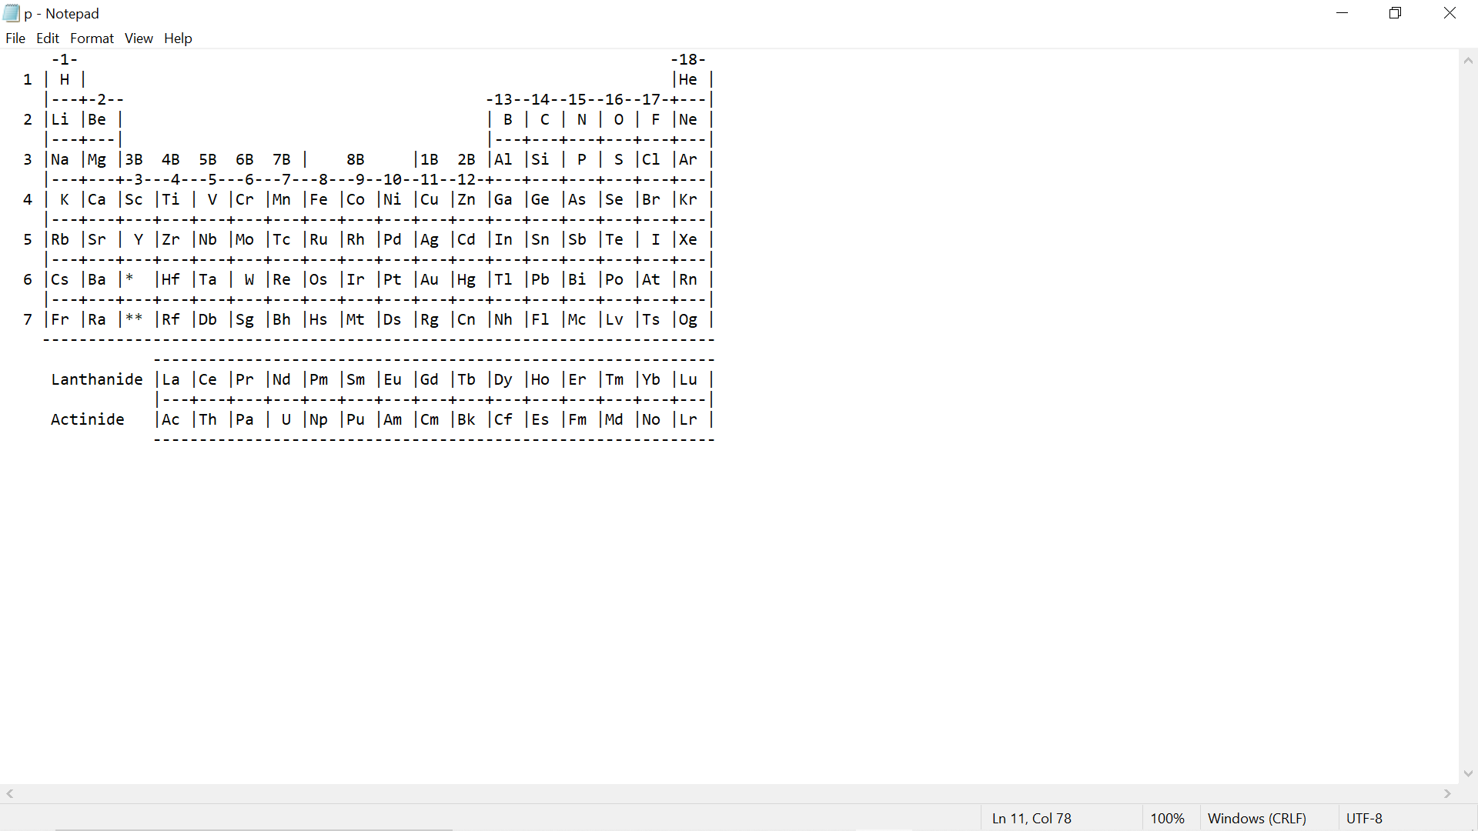

## **2.2 Product Functionality**

**Implementation Description –**

* **Header files –**

#include<iostream> #include<stdio.h>

#include<conio.h> #include<windows.h>

#include<string.h> #include<process.h>

* **Inbuilt Functions –**

1. goto() – this function helps us to directly go to any function we used in the program.
2. strcmpi() – this function is used to compare the two strings in the program.
3. strcpy() – this function is used to copy the one string as it is to another string.
4. clrscr() – this function is used to clear the screen and make the output window ready for the further execution.
5. getch() – this function is used to get the characters.
6. gets() – this function is used to get the string.
7. Main() – this function is used to access the main part of the program.

## **2.3 Design and Implementation Constraints**

In actual case, the program looks very easy to run but for developer it is quite a lengthy code.

# 3. Specific Requirements

## **3.1 User Interfaces**

The user should have a C++ compiler to run the code in any operating system (Linux is most preferable) and a bit knowledge about elements of periodic table as a prerequisite.

## **3.2 Hardware Interfaces**

The user should have PC or a laptop where he/she can run the program using compiler.

## **3.3 Software Interfaces**

Any C++ compiler is applicable for this project.

# 4. Other Non-functional Requirements

## 

## **4.1 Safety and Security Requirements**

There is no harm in using this project. But if in worst case any issue arises while compiling the program resulting in hanging of the device (PC, laptop, etc.) then for security purpose any antivirus software should be preinstalled in the device.

**4.2 Maintainability**

The Digital Modern Periodic Table have been developed in C++. It is an object-oriented programming language and easy to maintain.

**4.3 Portability**

The Digital Modern Periodic Table runs in any OS environment that has a g++ compiler installed in it.

**5. Design**

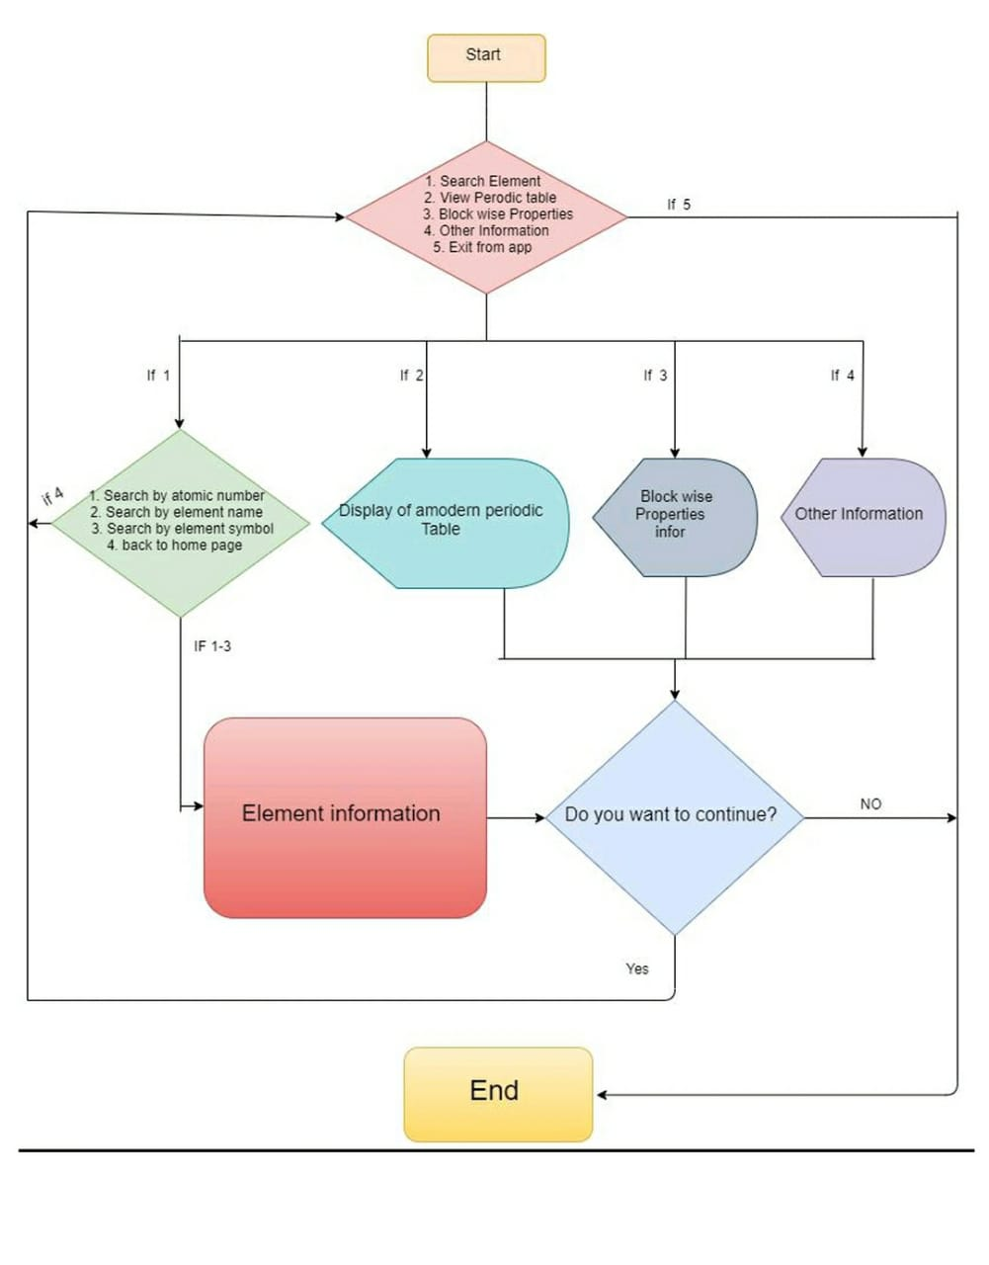

**6. Activity Diagram**

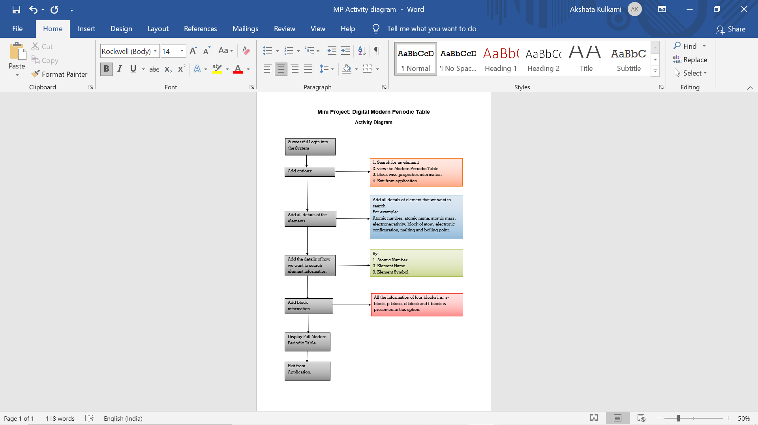

**7. Results**

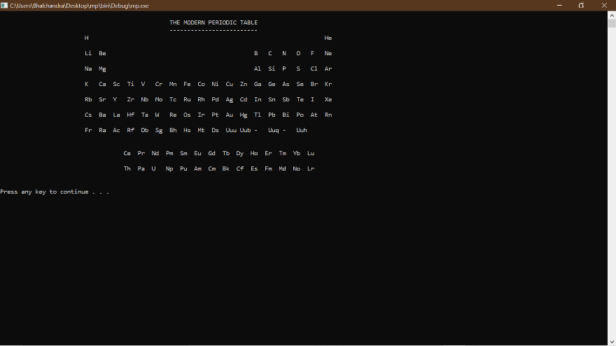

*Modern Periodic Table display window*

*Option Window*

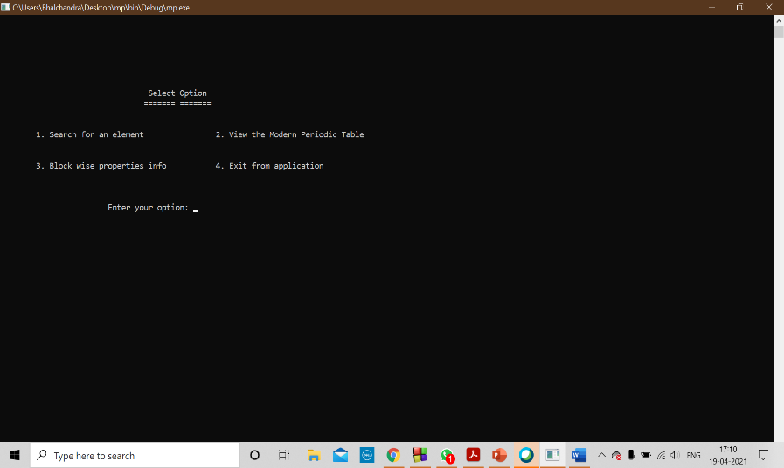

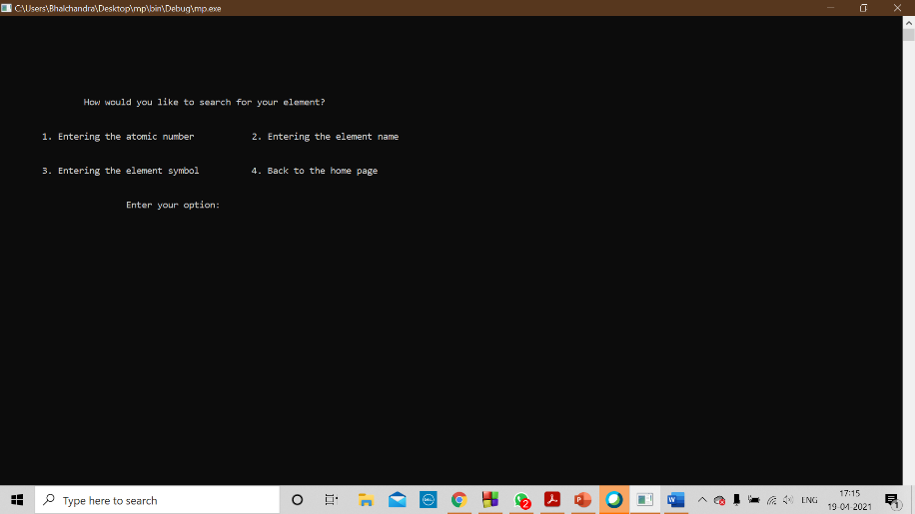

*Option 1 Window*

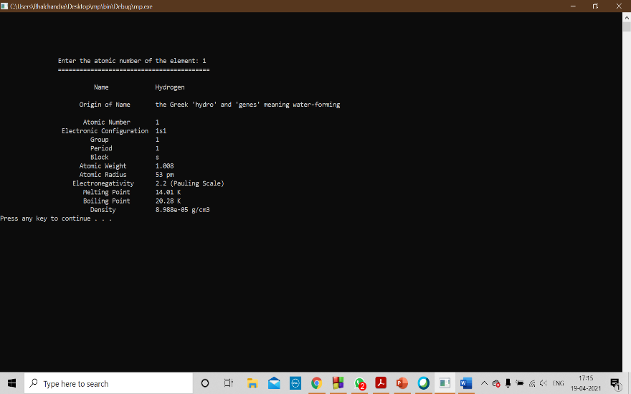

*Element information window*

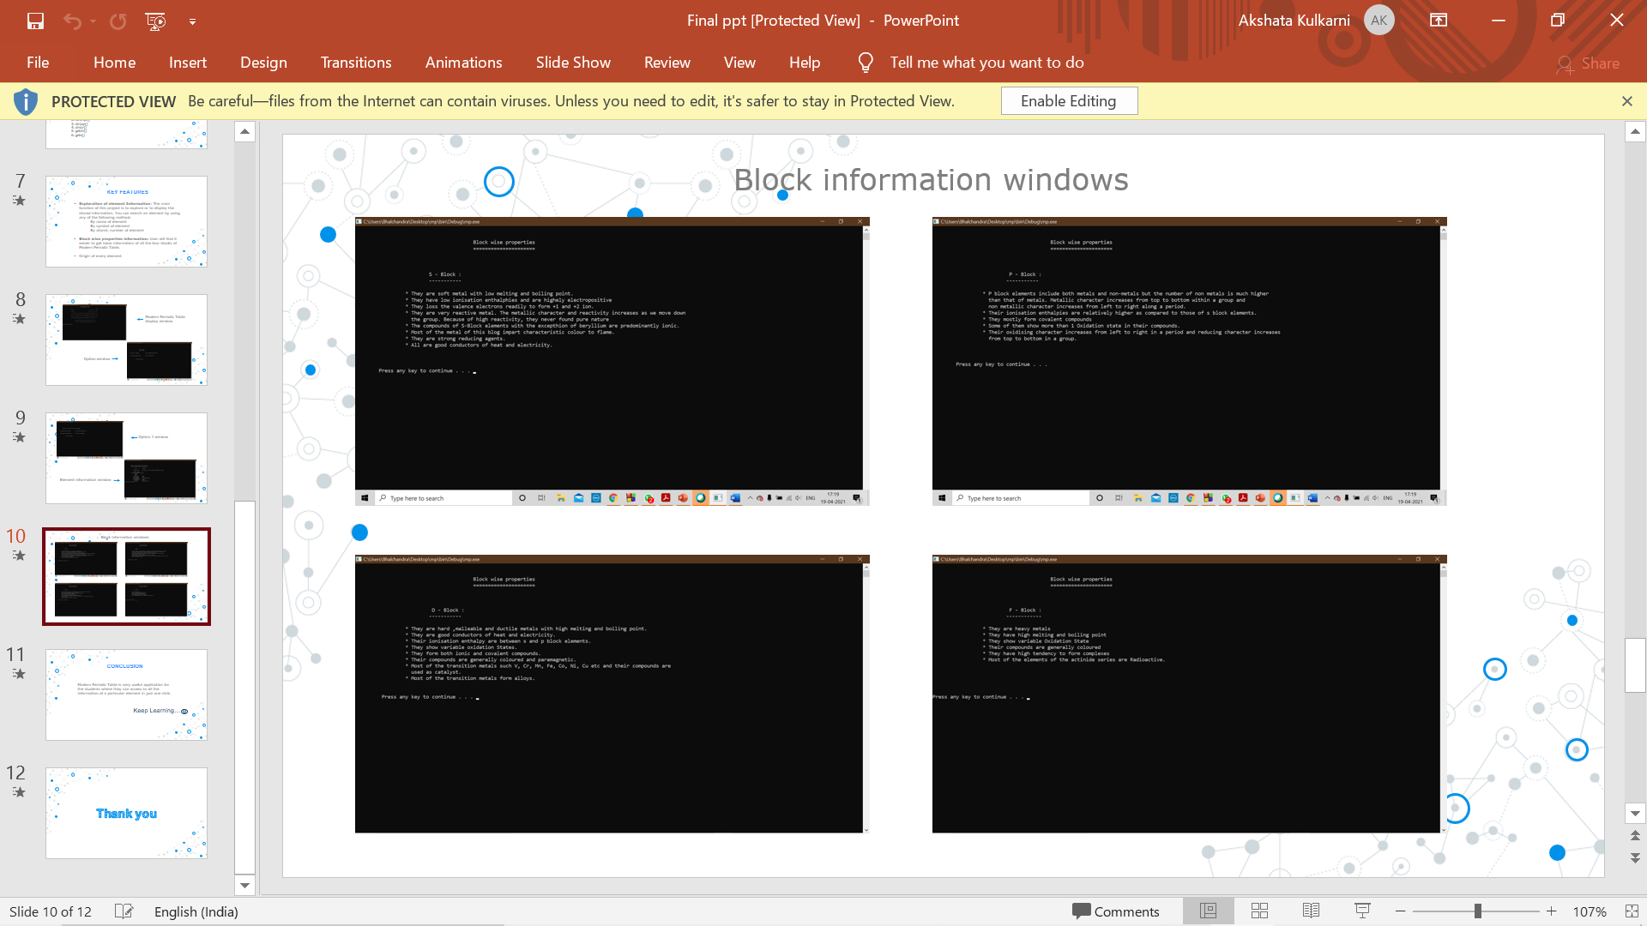

**Advantages**

* It is an error free developed software.
* It has very simple access to the user.
* Education based software.
* It is also free of cost.

**Disadvantages**

* Implementation of this software is bit complicated and lengthy.
* A good PC/smart phone and a compiler is must to run this software.

**Conclusion**

The main objective of the project was to develop an algorithm that will be used to access all the available information of each and every element in Modern Periodic Table that the user wants. It is a very useful application.

**References**

<http://cpp-project.blogspot.com/2011/12/computer-science-c-project-on-periodic.html>

<https://code-projects.org/periodic-table-in-c-with-source-code/>

<https://krazytech.com/projects>